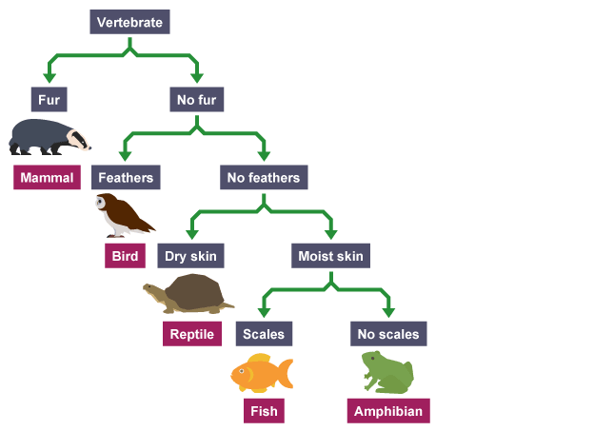**Year 7 Classification Test Revision – Answers**

1. Look at the dichotomous key for Vertebrates.
   1. What features are used to separate the organisms?
      1. Whether or not they have fur
      2. Whether or not they have feathers
      3. Whether their skin is dry or moist
      4. Whether or not they have scales
   2. What features does a bird have?
      1. Feathers; no fur; a backbone
   3. What features does a fish have?
      1. Scales; moist skin; no feathers; no fur; a backbone
2. Draw a branched dichotomous key for these animals.

* Rabbit
* Dog
* Cat
* Fish
* Guinea pig
* Bird
* Mouse
* Horse
  1. (Answers will vary.)

1. Write a tabular key for the branched key you drew in question 2.
   1. (Answers will vary.)
2. What are the three kingdoms of living things we have learnt about? Name two common features of organisms in each group.
   1. Plants (producers; have cell walls)
   2. Fungi (not producers; have cell walls)
   3. Animals (not producers; no cell walls)
3. Redraw, extend and complete the table to show the nine phyla we have learnt about in Kingdom Animalia.

|  |  |  |
| --- | --- | --- |
| **Phylum** | **Characteristics** | **Example** |
| Chordates | Have a spinal cord and backbone. | Monkey |
| Arthropods | Have an exoskeleton, jointed legs, and segmented bodies | (various) |
| Molluscs | Have soft bodies and often a protective shell |
| Nematodes | Worms with long, round bodies |
| Platyhelminths | Worms with flat or leaf-like bodies |
| Annelids | Worms with segmented bodies |
| Sponges | Have spongy bodies with holes |
| Cnidarians | Have soft, hollow bodies and stinging tentacles |
| Echinoderms | Have rough, spiny skin and repeated body parts around a central body |

1. For each of the animals below, name its phylum and explain your choice.
   * Starfish: echinoderm
   * Monkey: vertebrate
   * Ant: arthropod
   * Pelican: vertebrate
   * Prawn: arthropod
   * Snail: mollusc
   * Squid: mollusc
   * Sea urchin: echinoderm
   * Tape worm: platyhelminth
   * Leech: annelid
   * Meerkat: vertebrate
   * Jellyfish: cnidarian
2. Redraw, extend and complete the table to show the 5 classes of chordates.

|  |  |  |
| --- | --- | --- |
| **Class** | **Characteristics** | **Example** |
| mammal | Hair or fur; warm-blooded; produce milk; give birth to live young | (various) |
| bird | Feathers and scaly legs; warm-blooded; lay eggs with hard shells |
| reptile | Scaly skin; cold-blooded; most lay eggs; use lungs to breathe |
| amphibian | Soft, slimy skin; cold-blooded; lay soft eggs; gills when young → lungs when fully grown |
| fish | Scaly skin; usually cold-blooded; most have fins; use gills to breathe |

1. For each of the chordates below, name its class and explain your choice.
   * Turtle: reptile
   * Cow: mammal
   * Lizard: reptile
   * Duck: bird
   * Crocodile: reptile
   * Tree Frog: amphibian
   * Shark: fish
   * Magpie: bird
   * Cane toad: amphibian
   * Lion: mammal
   * Eagle: bird
   * Tuna: fish
   * Alligator: reptile
   * Moose: mammal
   * Echidna: mammal
   * Koala: mammal
2. Redraw, extend and complete the table to show the 4 classes of arthropods.

|  |  |  |
| --- | --- | --- |
| **Class** | **Characteristics** | **Example** |
| insects | 3 pairs of legs, 3 body parts | (various) |
| arachnids | 4 pairs of legs, 2 body parts |
| crustaceans | 5 or more pairs of legs, 2 or 3 body parts |
| myriapods | Many pairs of legs; many segments / worm-like body |

1. For each of the arthropods below, name its class and explain your choice.
   * Dung beetle: insect
   * Spider: arachnid
   * Earwig: insect
   * Scorpion: arachnid
   * Wasp: insect
   * Lobster: crustacean
   * Millipede: myriapod
   * Crab: crustacean
   * Butterfly: insect
   * Fly: insect